1)Install git

**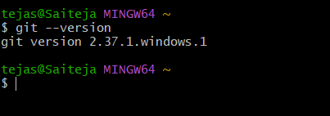**

**2)Create a repo in github with README.md and .ignore file.**

**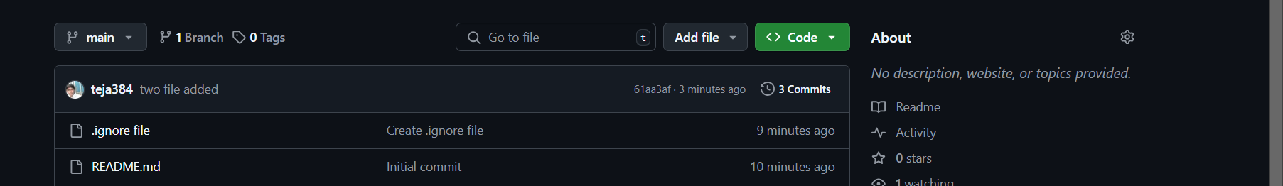**

**3)Clone the created repo to local.**

**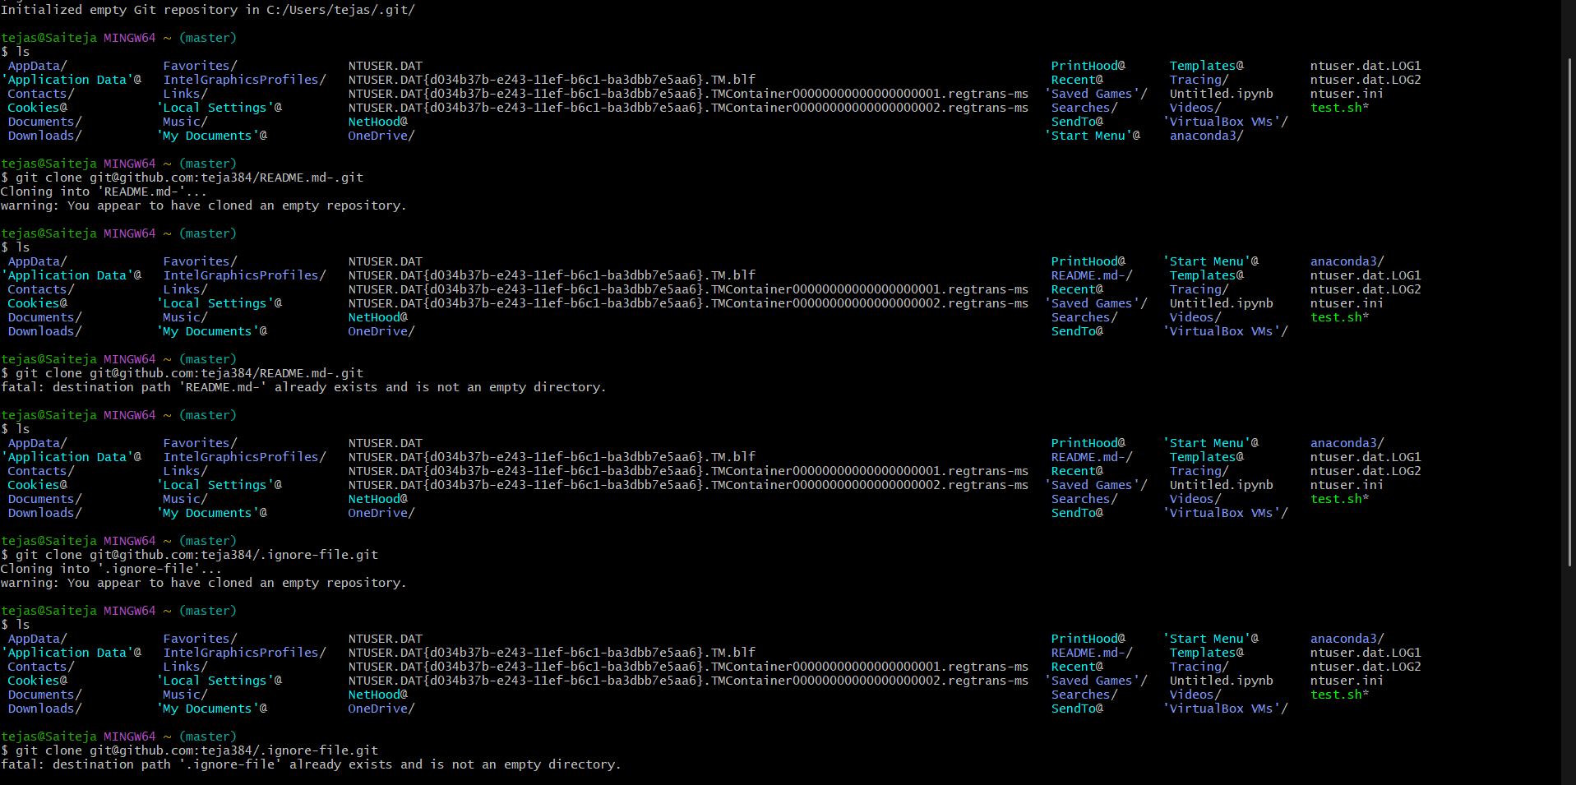**

**4)Create two files in local repo**

**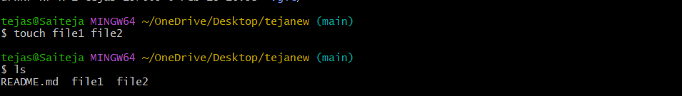**

**5)Commit two files and push to central Repository.**

**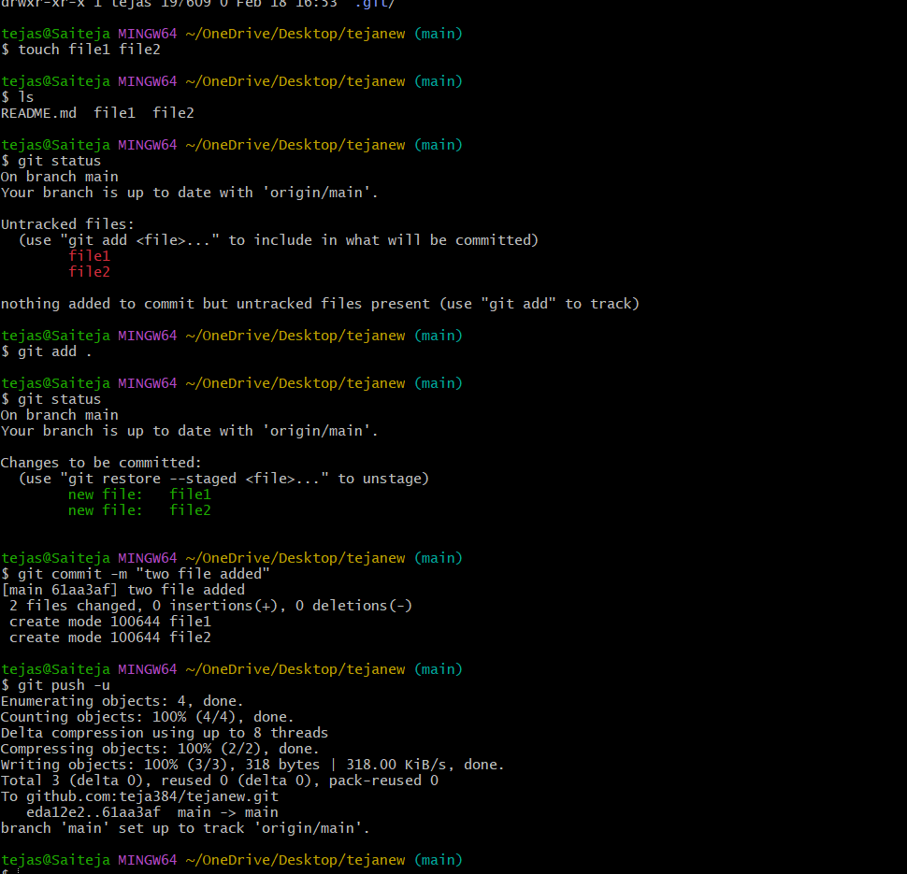**

**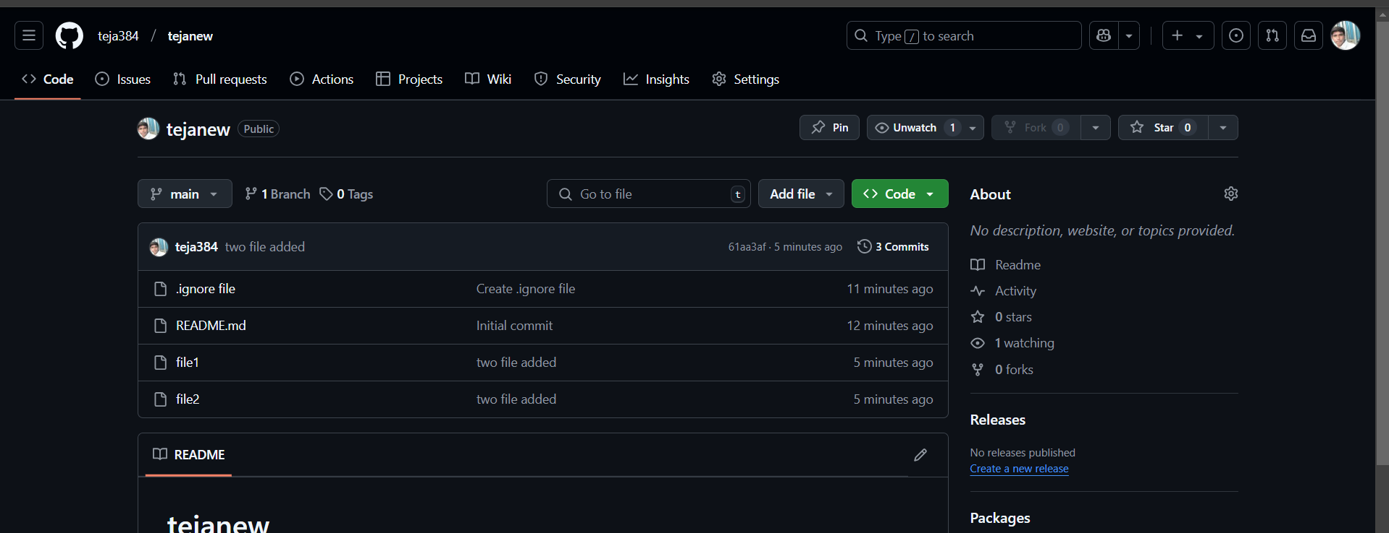**

**6)Create a branch in local and create a sample file and push to central.**

****

**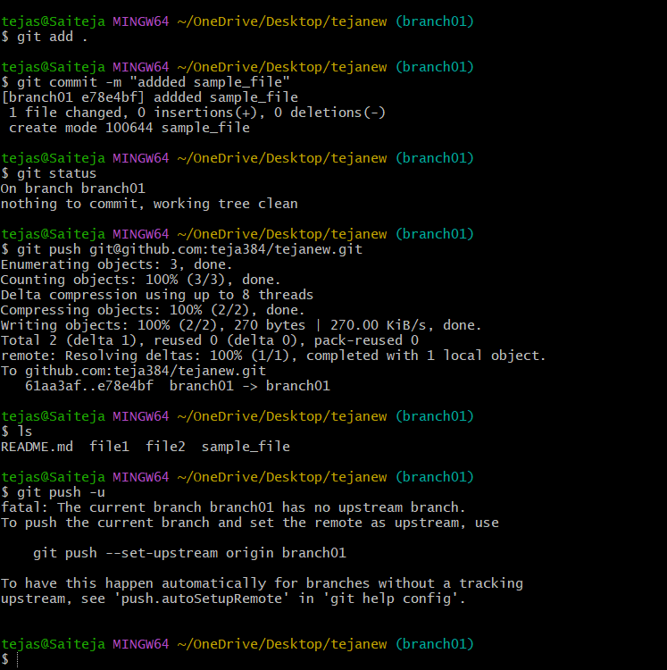**

**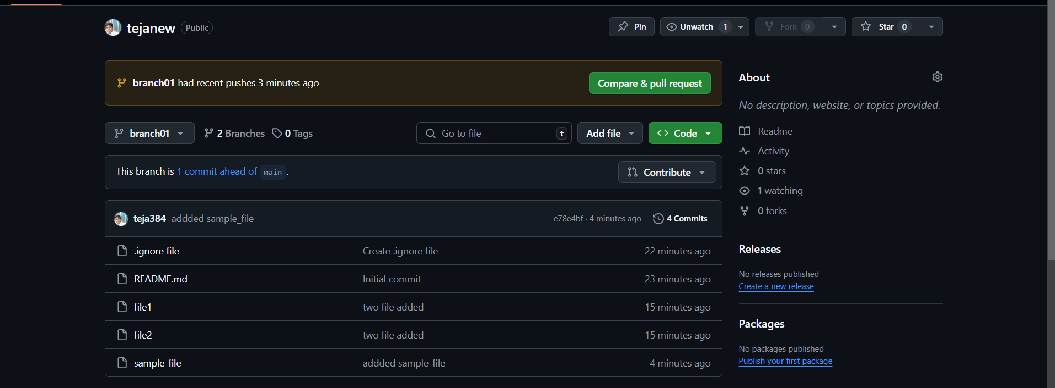**

**7)Create a branch in github and clone that to local.**

**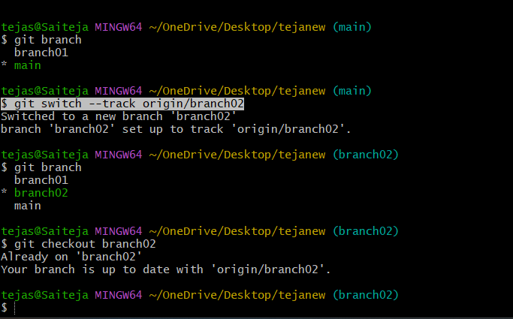**

**8)Merge the created branch with master in git local.**

**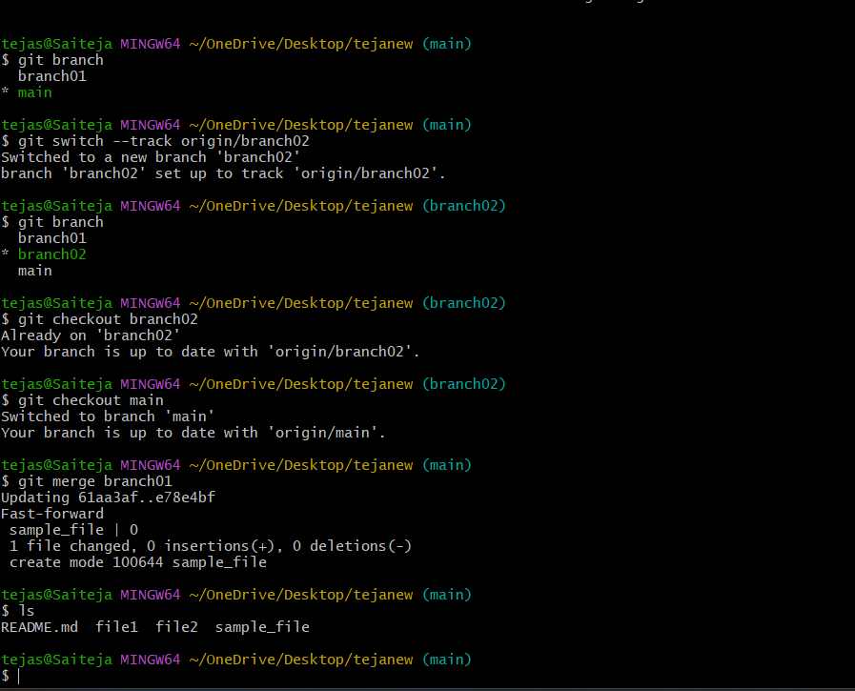**

**9)Merge the created branch with master in github by sending a pull request.**

**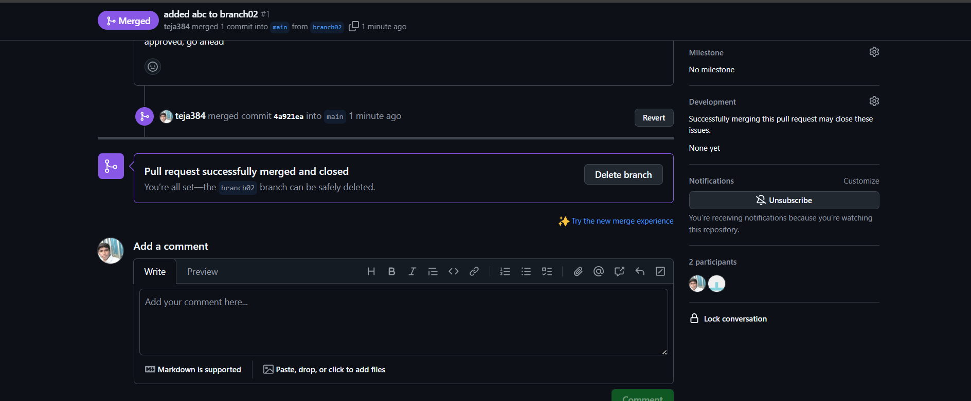**

**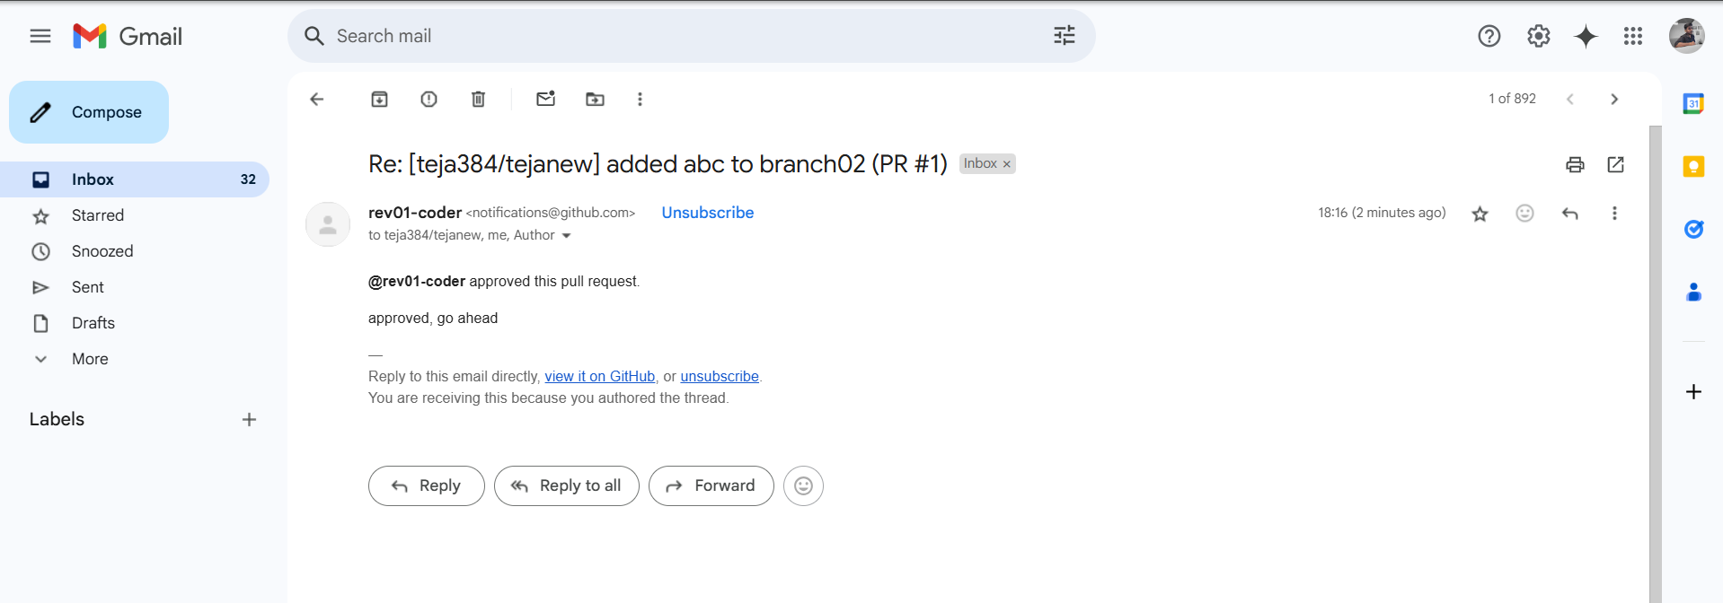**

**10)create a file in local and send that to branch in github.**

**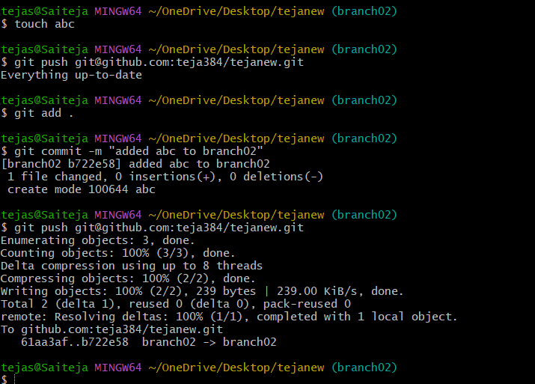**

**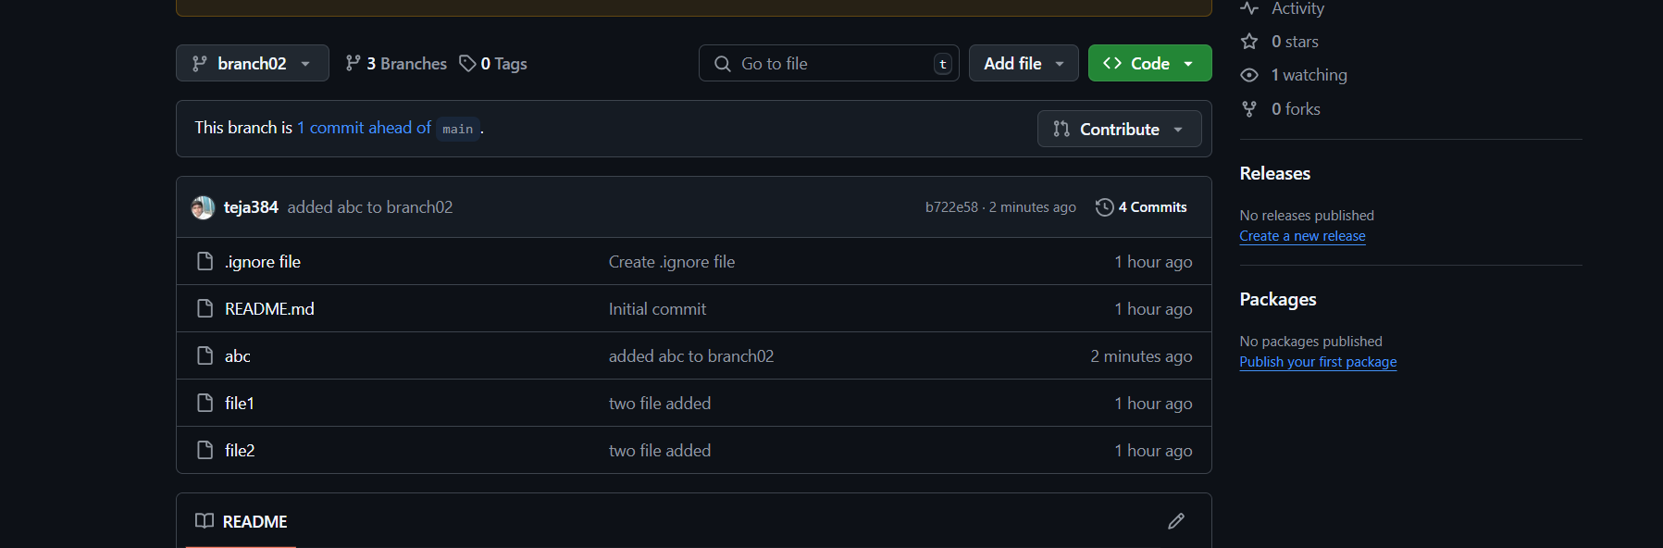**

**11)clone only a branch from github to local.**

**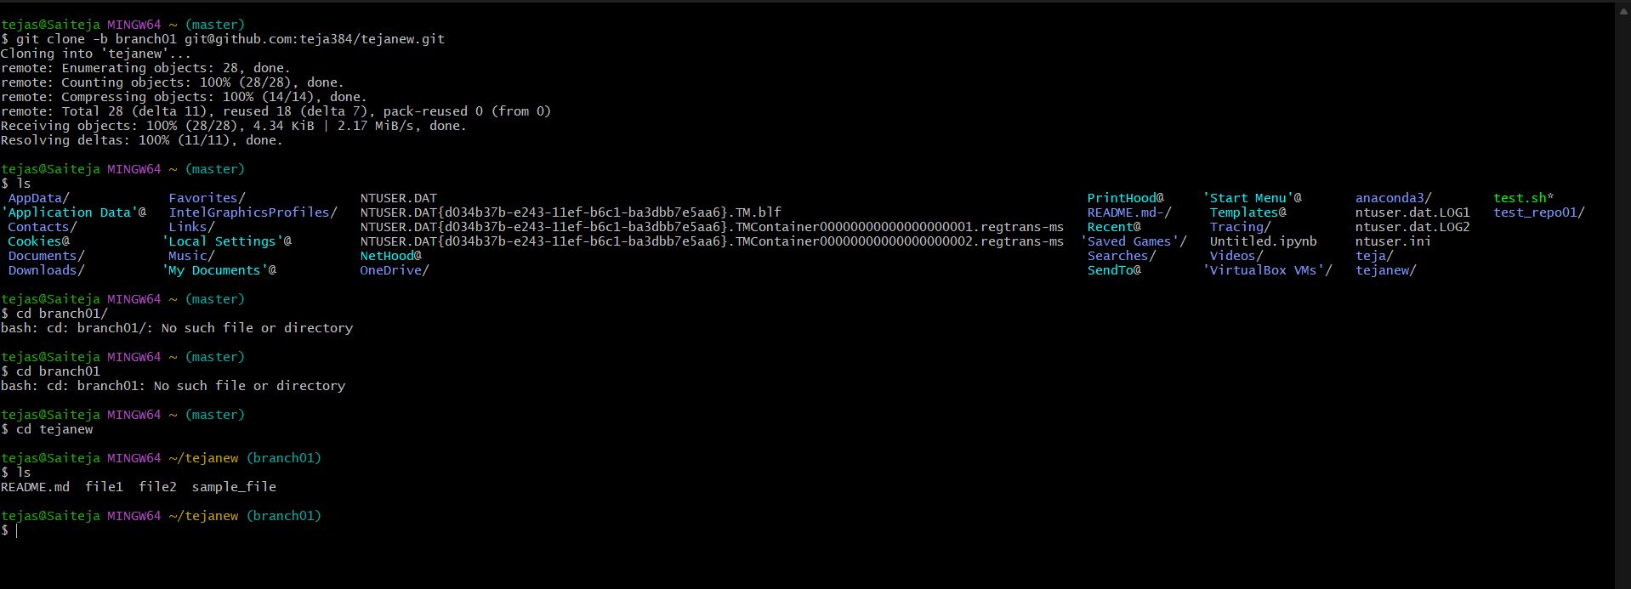**

**12)create a file with all passwords and make that untrackable with git**

**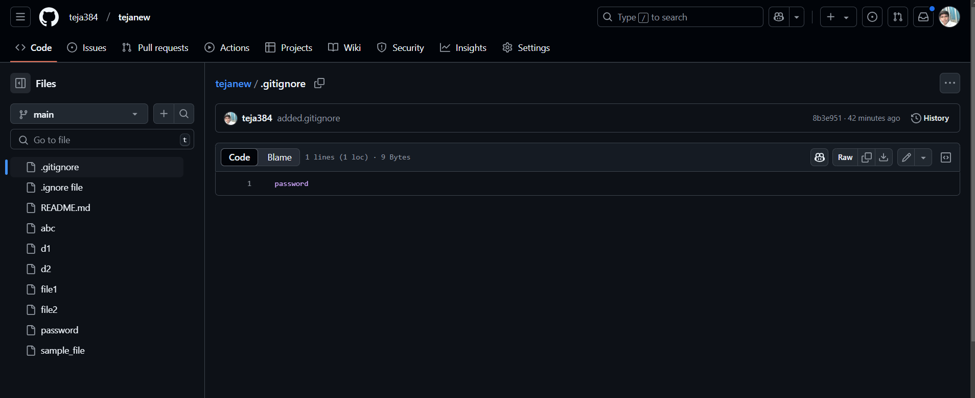**

**13)make a commit and make that commit reset without savings changes.**

**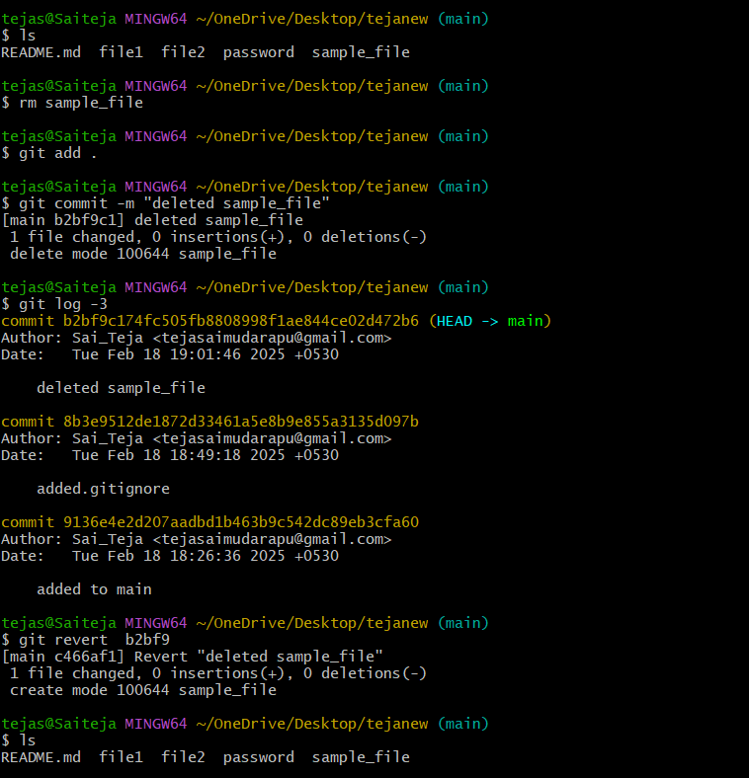**

**14)Revert a commited commit to the older version.**

****

**15)push a file to stash without savings the changes and work on another file.**

**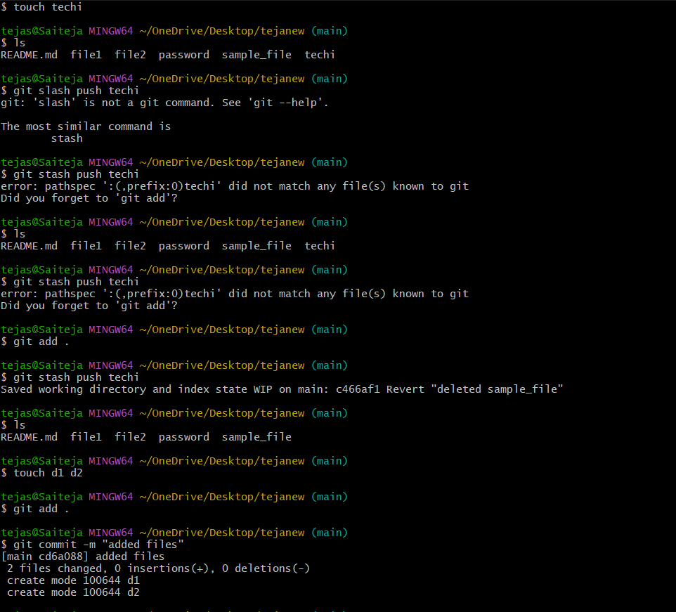**

**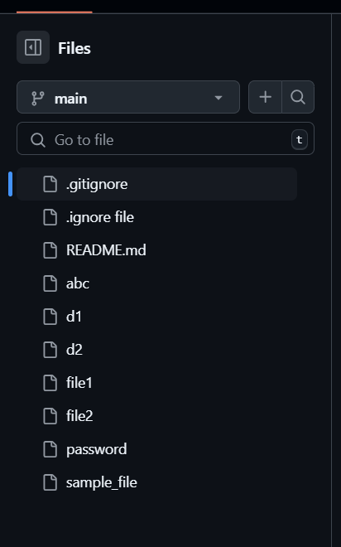**

**16)undo the stash file and start working on that again.**

**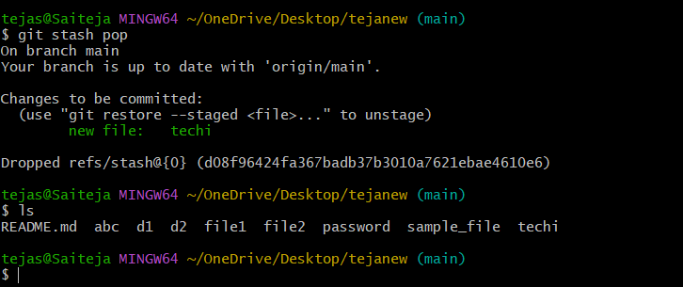**

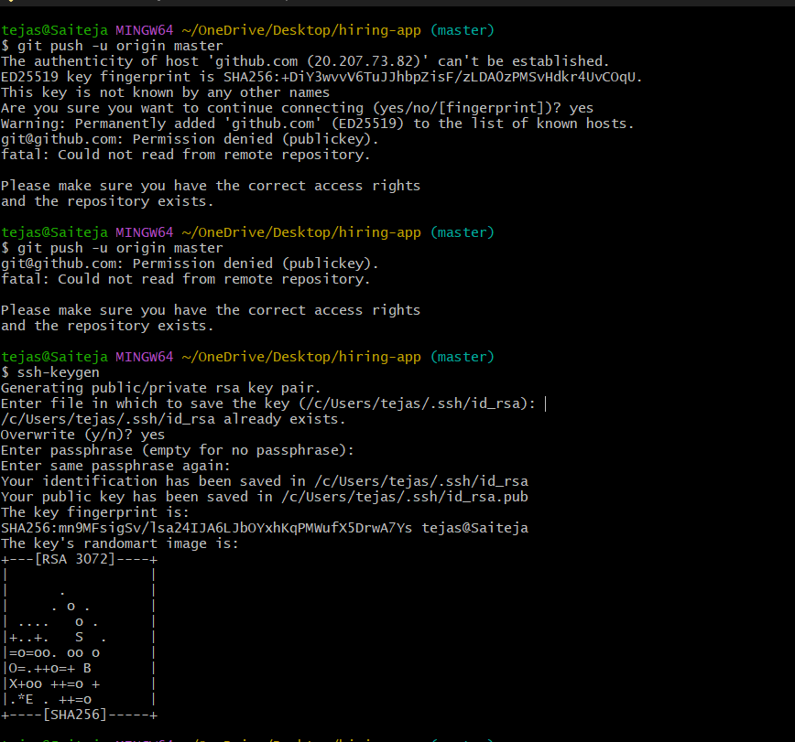**17)generate a ssh-keygen and configure into github.**

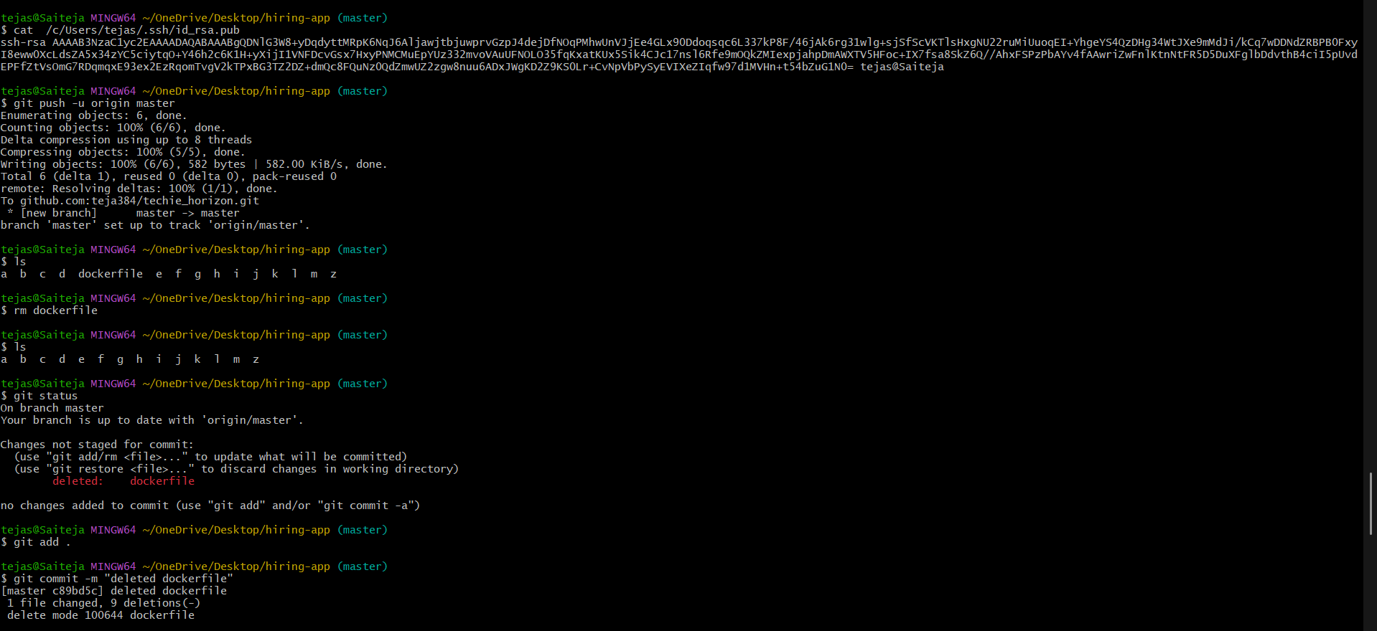

**18)configure webhooks to github.**

**--- launch ec2 and connect to ec2 and install Jenkins , java and git using below commands**

**wget -O /etc/yum.repos.d/jenkins.repo [https://pkg.jenkins.io/redhat-stable/jenkins.repo](https://pkg.jenkins.io/redhat-stable/jenkins.repo" \t "_blank)**

**sudo rpm --import**[**https://pkg.jenkins.io/redhat-stable/jenkins.io-2023.key**](https://pkg.jenkins.io/redhat-stable/jenkins.io-2023.key)

**yum install Jenkins -y**

**cat /var/lib/jenkins/secrets/initialAdminPassword**

**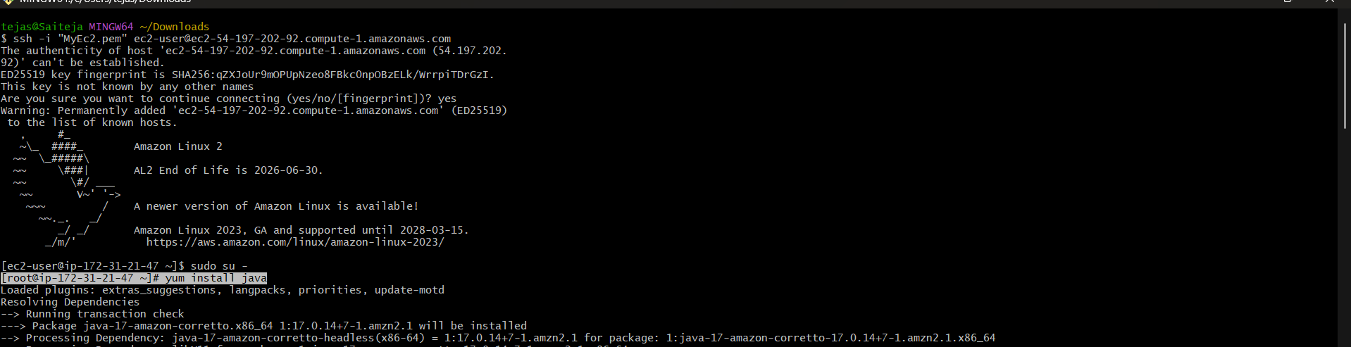**

**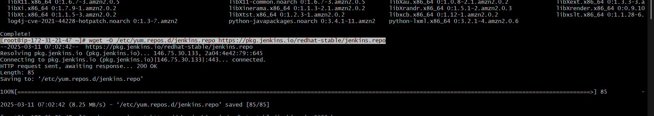**

**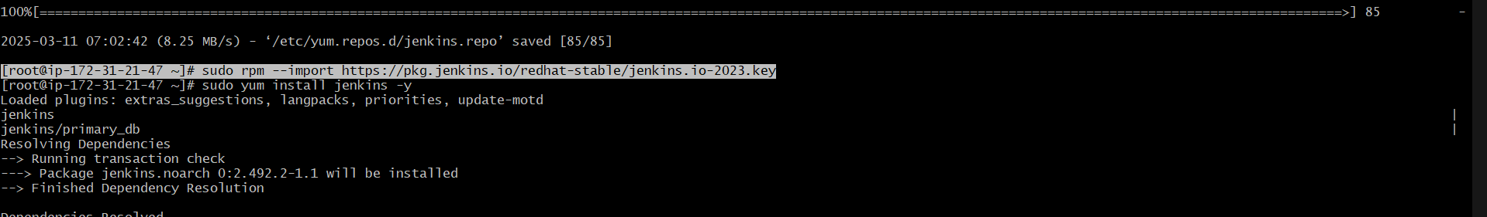**

**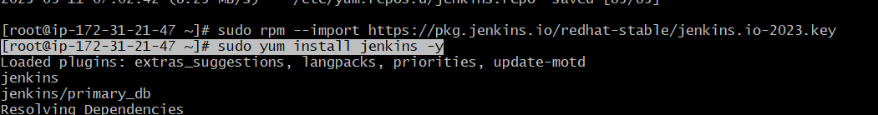  
---- copy&paste the password in browser**

**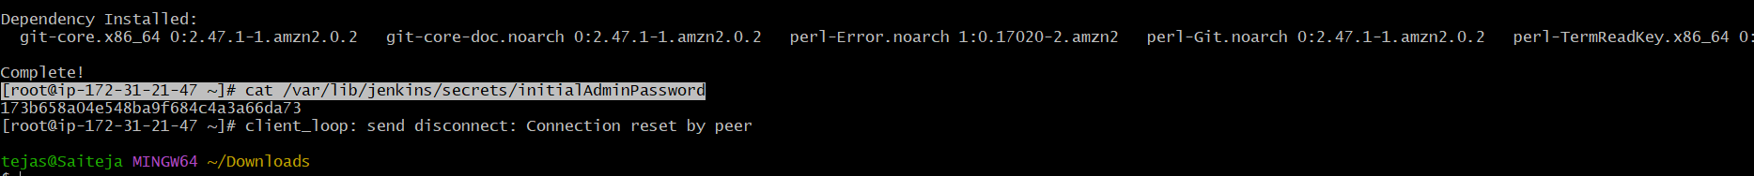**

**---- go to github and select one repo and create webhook**

**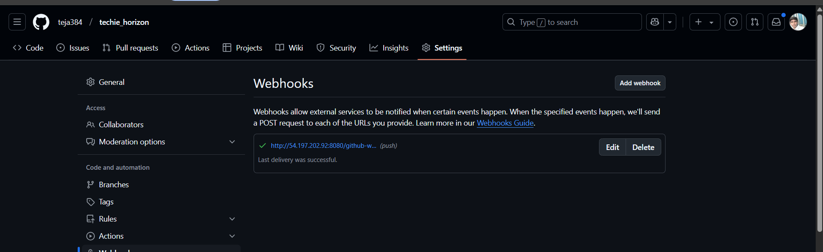**

**------ settings of creating webhooks in repo**

**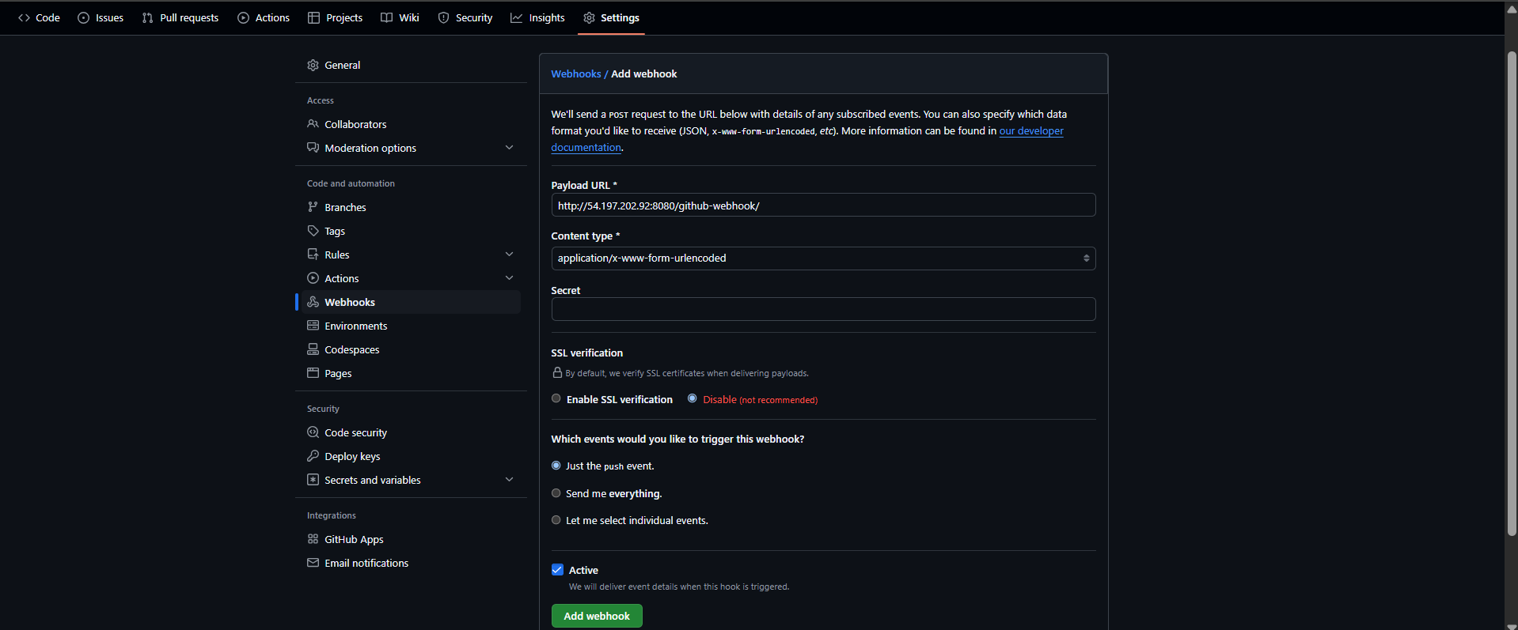**

**------ ---Create a job in jenkins dashboard**

**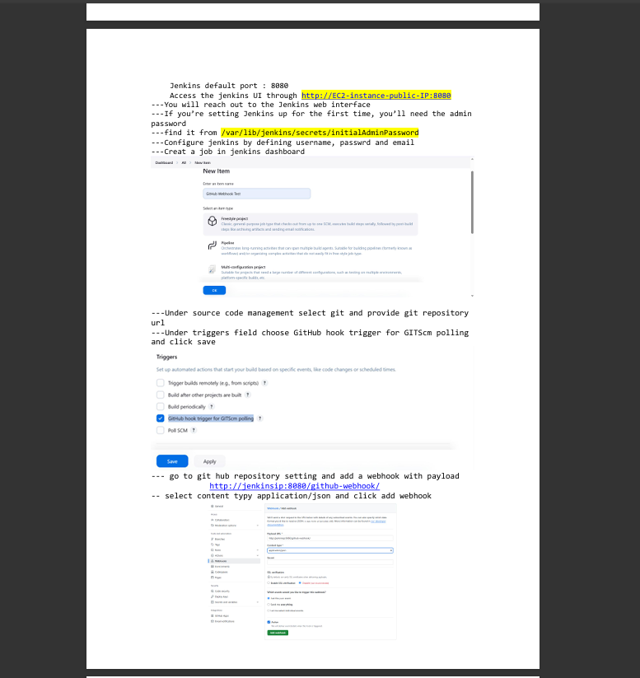**

**---- update or create new file in repo**

**----- go to Jenkins Dashboard → the build starts automatically.**

**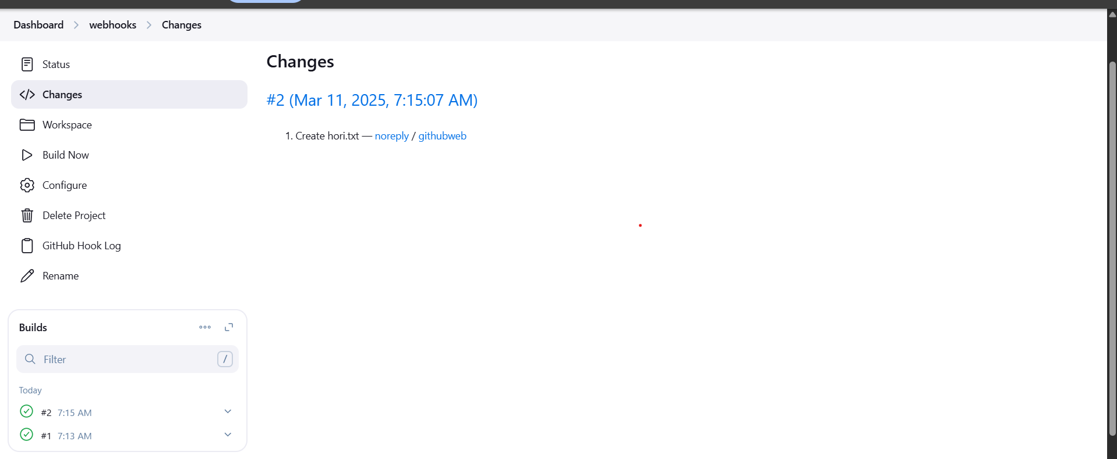**

**19)basic understanding of .git file.**

****

**20)Check all the logs of git**

**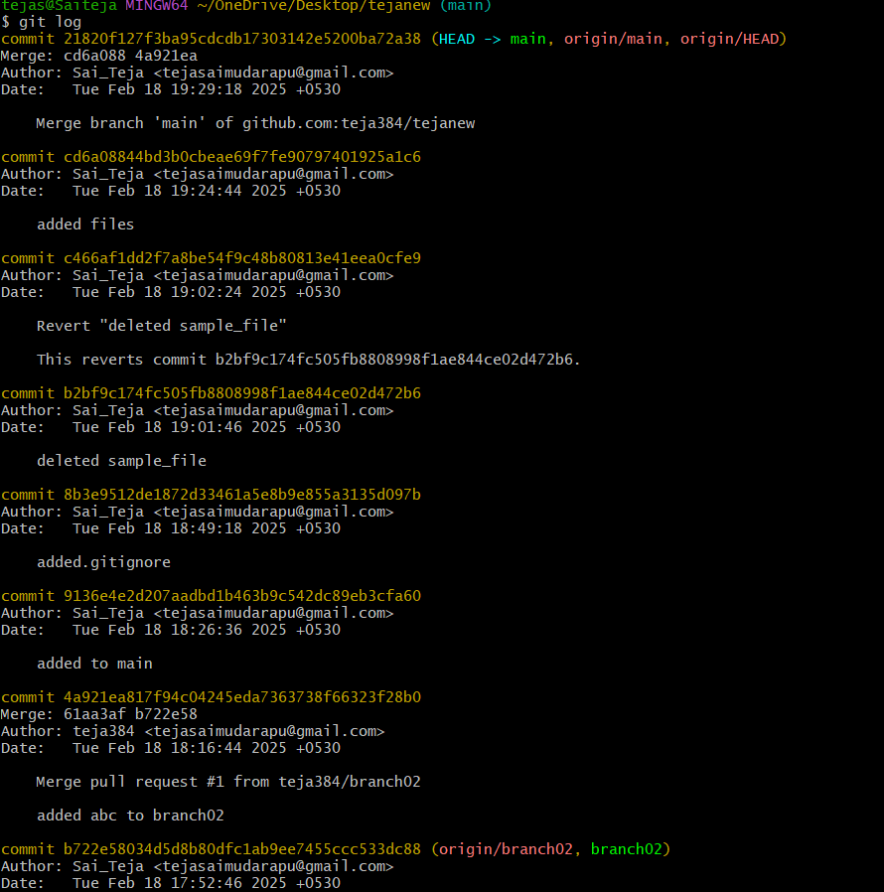**

**21)Rename the commit message.**

**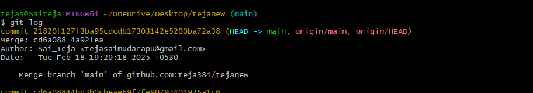**

**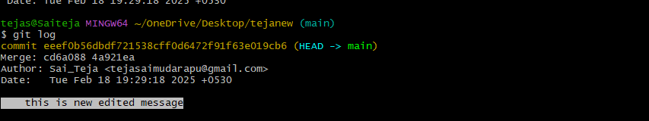**

**22)Merge multiple commits into single commit.**

**